

MINNESOTA STATE UNIVERSITY, MANKATO DEPARTMENT OF COMPUTER INFORMATION SCIENCE COMPUTER SCIENCE PROGRAM

USER DOCUMENTATION

THE MavPASS SCHEDULING PROJECT

Clients:
Dr. Laura Jacobi MavPASS Faculty Liaison

Lina Wang MavPASS Coordinator

THE MavPASS SCHEDULING TEAM
Madeline Ellingson Software Engineer
Hiruy Gebregiorgis Test Engineer
Justin Engels Database Engineer
Marilyn Croffie Team Lead

FACULTY COACH
Dr. Lin Chase

TABLE OF CONTENTS
Title Page 1
Table of Contents 2
Introduction 3
Purpose 3
Product Overview 3
User Manual 3
Minimum hardware and software requirements 3
Installation/Setup Guide 4
How to Run the Product 4
How to Access the Schedules 5
Troubleshooting 6
Key contacts 6

INTRODUCTION

Purpose

This document is an explanatory and informational manual that describes the product developed by the MavPASS Scheduling Team for its end-users. It is meant to assist end-users in using the product. The intended audience for this document is the clients.

Product Overview

This product takes the data populated in the database and creates a schedule based on hard and soft constraints. It then takes that schedule and exports it to excel in the following formats:

Day: Shows all the sessions in a daily format where the columns are labeled with the room and the rows are labeled with the time.
Room: Shows all the sessions in a particular room where each sheet is labeled with a room.
Master: A table of all sessions.

USER MANUAL

Minimum Hardware & Software Requirements

Minimum Requirements for Visual Studio 2022 Community
- 1.8 GHz or faster 64-bit processor; Quad-core or better recommended. ARM processors are not supported.
- Minimum of 4 GB of RAM.
- Hard disk space: Minimum of 850 MB up to 210 GB of available space, depending on features installed; typical installations require 20-50 GB of free space. We recommend installing Windows and Visual Studio on a solid-state drive (SSD) to increase performance.
- Video card that supports a minimum display resolution of WXGA (1366 by 768); Visual Studio will work best at a resolution of 1920 by 1080 or higher.
  - Minimum resolution assumes zoom, DPI settings, and text scaling are set at 100%. If not set to 100%, the minimum resolution should be scaled accordingly. For example, if you set the Windows to display ‘Scale and layout’ setting on your Surface Book, which has a 3000x2000 physical display, to 200%, then Visual Studio would see a logical screen resolution of 1500x1000, meeting the minimum 1366x768 requirement.

INSTALLATION/SETUP GUIDE

- Install visual studio community at the following link: https://visualstudio.microsoft.com/vs/community/

When you hit the Workloads screen make sure to check the box for ASP.NET and web development
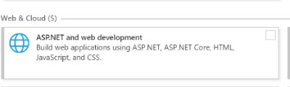
- Download and extract the zip file provided

HOW TO RUN THE PRODUCT

- Click into the unzipped folder and double click MavPASSScheduling.sln
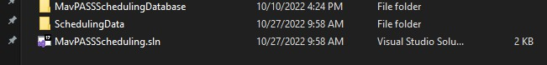

- Hit the play button in the top middle of the screen once Visual Studio opens up.
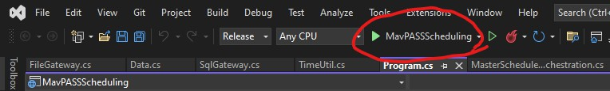

HOW TO ACCESS THE SCHEDULES

- Once the program finishes running (Approx 5 minutes) you can find the excel files by navigating inside the MavPASSScheduling folder.
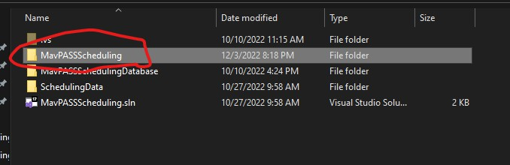
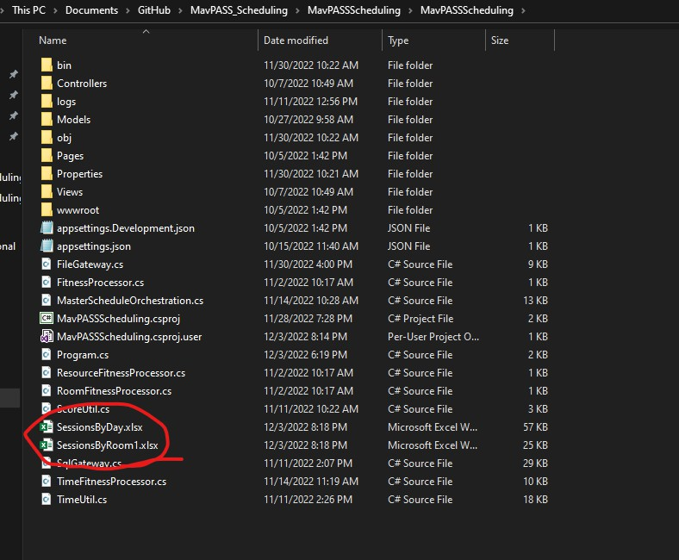

TROUBLESHOOTING

Please reach out to any of the key contacts for troubleshooting.

KEY CONTACTS

Dr. Lin Chase - lin.chase@mnsu.edu

Madeline Ellingson - madeline.ellingson@mnsu.edu Marilyn Croffie - marilyn.croffie@mnsu.edu
Hiruy Gebregiorgis - hiruy.gebregiorgis@mnsu.edu Justin Engels - justin.engels@mnsu.edu

